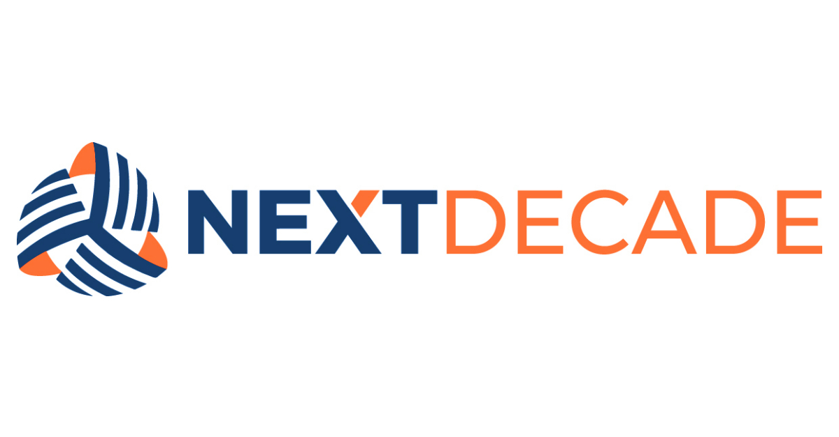
NAME
STANDARD DOCUMENT
xxx-xxx-xxx-xxx-xxx-#####
Table of Contents

A. INTRODUCTION 3
B. SCOPE 3
C. INTEGRATED GOVERNANCE FRAMEWORK 3
D. DEFINITIONS 3
E. REFERENCES AND RELATED DOCUMENTS 3
F. [CONTENT TITLE] 3
G. [CONTENT TITLE] 3
H. EXCEPTION REQUEST AND COMPLIANCE AUDITS 4
I. CONTINUOUS IMPROVEMENT AND REVIEW 4
J. OWNERSHIP 4
K. APPROVAL 4
REVISION HISTORY 5

INTRODUCTION
NextDecade Corporation ("NextDecade" or the "Company") is committed to [Define Purpose of Standard]. Compliance with the [Name the Standard] (“Standard”) is mandatory as governed by the [Name the Policy the Standard Links To].

SCOPE
This Standard defines and details acceptable ‘Levels of Quality’ and “Expectations” regarding [Describe the Area the Requirements Refer To]. The Standard applies to all employees, officers, directors, agents, consultants, contractors, and representatives, and any other individuals when they act on behalf of the Company (collectively “Workforce”).

INTEGRATED GOVERNANCE FRAMEWORK
This Standard is part of NextDecade’s integrated Governance Framework. The Workforce must understand and comply with this Standard and all other Governance Framework Policies, Standards, and Procedures.

DEFINITIONS
No. | Term | Definition

REFERENCES AND RELATED DOCUMENTS
Title | Document Number

[CONTENT TITLE]
[Content Description]
  - [Content Detail]
    - [Content Detail]
      - [Content Detail]

[CONTENT TITLE]
[Content Description]
  - [Content Detail]
    - [Content Detail]
      - [Content Detail]

EXCEPTION REQUEST AND COMPLIANCE AUDITS
When compliance is not feasible or technically possible or when deviation is necessary to support a business function, requests for exceptions to any term or requirement of this Standard must be made to the [Name Party / Role]. The Company will work in good faith to address the exception request but reserves the right to require compliance with this Standard in all cases.

CONTINUOUS IMPROVEMENT AND REVIEW
This Standard will be reviewed at least annually to ensure it remains current and relevant. The Workforce will be informed of any significant revisions in a timely manner.

OWNERSHIP
Responsible | Accountable | Consulted | Informed

APPROVAL
Issuer / Title | Adopted By | Effective / Amended Date
s/ | NextDecade Corporation

REVISION HISTORY

Revision | Description of Changes and Notes
0 | Issued for Use

The Governance Framework outlines the rules, practices, and processes by which the Company is directed and controlled ensuring accountability, fairness, and transparency in the Company's relationship with its stakeholders, including shareholders, employees, customers, and the community.

